This Week at PPBC





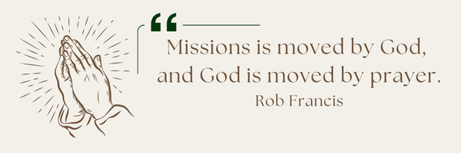
A message from Anjou: Pray for wisdom as they navigate the relocation of sister churches in the area. This will, potentially, impact their target community (Anjou). Pray for clarity in communication with other pastors and leaders.

Coming Soon
Tuesday, January 6th

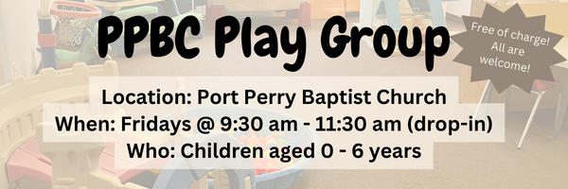

January 10th, 2025

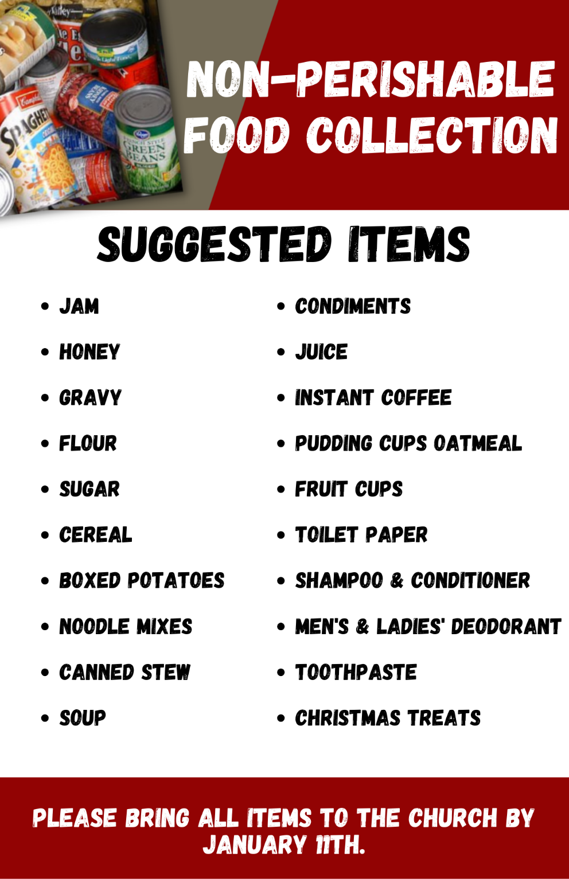

Sunday Ministry Schedules
Below are ministry schedules for Nursery, Jr. Church, Greeters, Ushers, and Sound & Video:
Nursery
Dec 21: Brenda Clemens, Audrianna Angrove
Dec 28: Jen Werner, Brantley Colwell
Infant Nursery
Dec 21: Stephanie Anderson, Karis Henkelman
Dec 28: Laura Saunders, Amber Saunders
Jr. Church; ages 3 to grade 1
Dec 21: Ellianne McLaren, Hailey Ferguson
Dec 28: Deb Brown, Grace Brown
Jr. Church; Grades 2 to 6
Dec 21: Miriam Bolsonello, Tiffany Green
Dec 28: Kate Anderson, Graeme Anderson
Greeters
Dec 21: Paul & Helen Jones
Dec 28: Graeme & Barb Foster
Ushers
Dec 21: Nick Woytowich, Gregg Anderson
Dec 28: Mark McLaren, Roy Wilson
Sound & Video
Dec 21: Sound: Jordan Anderson | Video: William Conley
Dec 28: Sound: Wyatt Werner | Video: Josh Bolsonello


Morning Service
Song – Joy to the World
Welcome
Song – Angels We have Heard on High
Advent Reading
Song – Immanuel
Prayer
Song – It Came Upon a Midnight Clear
Message – Pastor Jim Clemens
Song – Christmas Sanctus (Holy, Holy, Holy)

Praise & Prayer Highlights
PRAY for Joan Mabley and her ongoing health concerns. Joan has been moved to Lakeridge Health Bowmanville unit #1 room #108 bed #1.
PRAY for Alice White and her ongoing recovery.
PRAY for Martin & Tina McCurley. Tina has some shoulder injuries. PRAY for her healing and recovery.
PRAY for Bert & Ada Faber. PRAY for Ada who is in Port Perry Hospital room #119 for observation.
PRAY for Andrew and Gladys Alexander. PRAISE that Andrew is now home from Hospital. PRAY for his health and recovery and for Gladys as she cares for her husband.
PRAY for Winnie Miller and her ongoing health concerns.
PRAY for New Song Church & Port Perry Baptist as they plan to co-host a Christianity Explored outreach at That Place on Queen in the new year. Please PRAY for God to prepare the hearts of those who will attend from the community to receive the gospel.
Thank you to the ladies who helped Betty Collins with her Christmas shopping and wrapping.

Giving
Just as a reminder, there are several ways you can give:
In Person using the offering box located on the back wall of the sanctuary. Donation envelopes are available at the Welcome Centre. Please contact the church office if you would like a box of donation envelopes (office@portperrybaptist.ca)
Through your online banking, you may send electronic transfers to ppbcdonations@gmail.com.
You can also give through Canada Helps. Donation receipts will be provided by Canada Helps, and transaction fees apply.
***********************************************************************
Weekly Newsletter
The PPBC Newsletter is emailed to the church family every Friday. If you would like to be added to the weekly email list, please contact the office by phone: 905-985-8681 or by email: office@portperrybaptist.ca.
*****************************************************************
Church Information:
Location:
2210 Hwy 7A
Port Perry, ON
L9L 1B4
Office Hours:
Monday: 8:30am – 4:00pm
Tuesday: 8:30am – 4:00pm
Wednesday: Closed
Thursday: 8:30am – 4:00pm
Friday: 8:30 am - 3:00 pm
Contact:
Phone: 905.985.8681
Email: office@portperrybaptist.ca
Website: www.portperrybaptist.ca
Staff:
Sr. Pastor – Rev. Jim Clemens
Administrative Assistant – Madeline Werner
Family Ministries Director – Josh Anderson

PPBC Newsletter
Sunday, December 21, 2025


Sunday Starting Point
Sunday, December 21, 2025 - 9:30 am
“Beginning the day with the Word and prayer”
Adults:
Adults will meet in the sanctuary for a time of study and prayer. Psalm 148.
Youth:
Jr High (Grades 7-8) will meet in room 18 with Kate Anderson to study Advent.
Children:
Children ages 3 - grade 6 will meet in room 26.
(Please note nursery is unavailable during Starting Point)
Sunday Morning Worship
Sunday, December 21, 2025 - 10:30 am
We are meeting in the sanctuary and will continue to live-stream for those who are unable to attend.
Message: The King on His Throne
Scripture: Revelation 4-5
Pastor Jim Clemens

