****Monday, September 18, 2023

 The ladies meet Monday evenings at 7:00 pm at the church. Zoom will be available for those who are unable to attend in person. Please contact the office or speak to Deb Brown if you plan to attend so we can order books!

*************************************************************************

Tuesday, September 12, 2023

The ladies meet every Tuesday morning at 9:30 am. We will be starting God of Deliverance by Jen Wilkin. Contact Karen Ballanger at [tkballanger@gmail.com](mailto:tkballanger@gmail.com) or 905-985-9518 if you have any questions.

**

**Saturday, September 9, 2023, Men's Breakfast and Bible Study 7:30 am at the church**

**

Ladies! You are all invited to celebrate with Sunny Lin on Sunday, September 17th after service. Sign up at the welcome center.

As the couple will not have a lot of space in their future home, they have requested no gifts. Due to this, we will be asking for any ladies who wish to join us in blessing the couple to provide a recipe for a meal, a dessert or both to be compiled in a recipe book from the women of the church. If you feel so inclined you can also make a monetary gift to the couple. Please send any recipes to the church office email or drop them off at the office by September 10th.

***********************************************************************

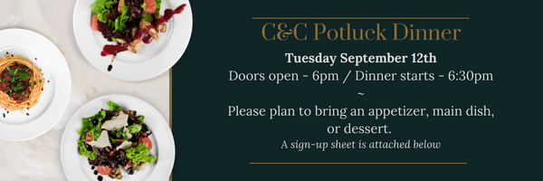

It is highly encouraged for everyone to invite friends, we'd like to see as many people attend as possible, both old and new faces! Please note, guests do not need to bring anything

If you have any questions, please speak to Caleb Bolsonello

**Grass-Cutting Volunteers**

If you would be able to assist with cutting the grass at the church, please sign up at the Welcome Centre. If you have any questions, please speak to Joe Colwell.

*************************************************************************



**Men's Prayer**

**Thursday, September 7, 2023 - 7:30am**

The men meet every Thursday @ 7:30am for prayer.

*************************************************************************

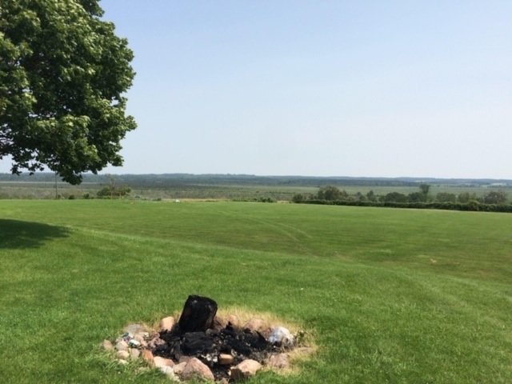

**Kick Off Sunday**

Join us September 10th after the morning service for a time of fellowship, food and games. Don’t forget your lawn chair or blanket!

**Sunday Ministry Schedules**

**Nursery**  
**September 3:**Deb Brown, Grace Brown  
**September 10:**Melanie Colwell, Mary-Jayne Brown

**Jr. Church; ages 3 to grade 1**  
**September 3:**Gregg & Karen Anderson, Bethany Summers  
**September 10:**Deb Brown, Elise Anderson

**Jr. Church; grade 1-6**  
**September 3:**Gregg & Karen Anderson, Bethany Summers  
**September 10:**Tracy Ballanger, Andrea Sammut

**Greeters**  
**September 3:**April & Les Saunders  
**September 10:**Jeannine & Ken Poole

**Sound & Video**  
**September 3:**Sound: Caleb Bolsonello | Video: Josh Myers  
**September 10:**Sound: Charlie Deane | Video: TBA

*\*\*\*\*\*\*\*\*\*\*\*\*\*\*\*\*\*\*\*\*\*\*\*\*\*\*\*\*\*\*\*\*\*\*\*\*\*\*\*\*\*\*\*\*\*\*\*\*\*\*\*\*\*\*\*\*\*\*\*\*\*\*\*\*\*\*\*\*\*\*\*\*\*\*\*\*\**

**

Calling all musicians, singers, audio, visual and all those who are interested in helping with worship!

Worship meeting Sunday September 24th at 4pm

**Praise & Prayer Highlights**

**Sunday, September 3rd, 2023**

* **PRAISE** that the *Persis Family* has arrived. Continue to **PRAY** for them as they adjust to their new home.
* PRAY for *Ewald Bengal* who is being treated for a heart condition and waiting on surgery. **PRAY** for the doctors and nurses who will be caring for him and for his family.
* **PRAY** for the upcoming ministry year. **PRAY** for our ministry leaders and helpers as they prepare and for the hearts and minds who will be receiving those ministries.
* **PRAY** for Anne Hale who is healing after surgery from her fall. **PRAISE** that the surgery went well and for the doctors and nurses who assisted. Thank you for your prayers.
* **PRAY** for *Joanna Malcolm and her family* as they mourn the loss of their Dad, Grandpa, and Opa, *John Wolters*. **PRAY** that God would guide them through the coming days and provide His peace.
* **PRAY** for Bill Durnan as he is in Port Perry Hospital due to ongoing health concerns.
* Please **PRAY** for Ken and Jeannine Poole. **PRAY** that God would give physical recovery and spiritual comfort and strength as he continues treatments.
* **PRAY** for those who suffer from chronic illness and pain. **PRAY** they will know God’s sustaining grace, peace, and comfort daily.
* **PRAY** for the family in the local equestrian community. The husband has since passed away. **Prayers** for peace and wisdom for the family. **Prayers** that those around them would be able to be effective witnesses and support them as best they can.
* **PRAY**for those returning to school this year from preschool to college and university.

**Coming this Fall!**



Starting October 4th

Register Now!

For Youth in grades 7-12

Fridays 7:30pm – 9:30pm

A time of study and games





Recently joined our church? Looking to connect with fellow believers in your area? Want to study the word of God in depth?

Speak to Tracy Ballanger about joining a small group.

**Giving**

Just as a reminder, there are a number of ways you can give:

**In Person** using the offering box located on the back wall of the sanctuary. Donation envelopes are available at the Welcome Centre. Please contact the church office if you would like a box of donation envelopes (office@portperrybaptist.ca)

**Through your online banking**, you may send electronic transfers to ppbcdonations@gmail.com.

**You can also give through Canada Helps**. Donation receipts will be provided by Canada Helps, and transaction fees apply.

**************************************************************************

**Church Information:**

**Location:**

2210 Hwy 7A

Port Perry, ON

L9L 1B4

**Office Hours:**

Monday: 8:30am – 4:00pm

Tuesday: 8:30am – 4:00pm

Wednesday: Closed

Thursday: 8:30am – 4:00pm

Friday: 8:30 am - 3:00 pm

**Contact:**

Phone: 905.985.8681

Email:office@portperrybaptist.ca

Website: www.portperrybaptist.ca

**Staff:**

Sr. Pastor – Rev. Jim Clemens

Administrative Assistant – Madeline Werner

Children’s Ministry Coordinator – Jenna Bryant

**PPBC Newsletter**

**Sunday, September 3rd, 2023**

**Weekly Newsletter**

The PPBC Newsletter is emailed to the church family every Friday. If you would like to be added to the weekly email list, please contact the office by phone: 905-985-8681 or by email: office@portperrybaptist.ca. Hard copies are available on

Sundays at the Welcome Centre.

****\*\*\*\*\*\*\*\*\*\*\*\*\*\*\*\*\*\*\*\*\*\*\*\*\*\*\*\*\*\*\*\*\*\*\*\*\*\*\*\*\*\*\*\*\*\*\*\*\*\*\*\*\*\*\*\*\*\*\*\*\*\*\*\*\*\*\*\*\*\*

**Sunday Starting Point**

**Sunday, September 3rd, 2023 - 9:30 am**

*“Beginning the day with the Word and prayer”*

**Adults & Youth:**

Adults and youth will meet in the sanctuary for a time of study and prayer.

*(Please note nursery & jr church are unavailable during Sunday School)*

**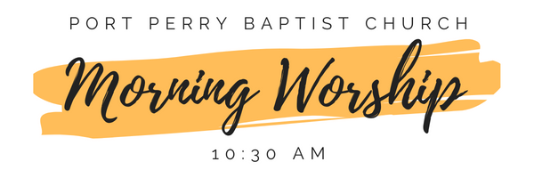***\*\*\*\*\*\*\*\*\*\*\*\*\*\*\*\*\*\*\*\*\*\*\*\*\*\*\*\*\*\*\*\*\*\*\*\*\*\*\*\*\*\*\*\*\*\*\*\*\*\*\*\*\*\*\*\*\*\*\*\*\*\*\*\*\*\*\*\*\*\*\*\*\*\*\*\*\**

**Morning Worship & Live-Stream**

**Sunday, September 3rd, 2023 - 10:30 am**

We are meeting in the sanctuary and will continue to live-stream for those who are unable to attend.

Message: The Five Solas

Scripture: Galatians 1

Speaker: Steve Angrove